

***Front-end React***

**Training Assignment**

|  |  |
| --- | --- |
| Document Code | 25e-BM/HR/HDCV/FSOFT |
| Version | 1.1 |
| Effective Date | 20/11/2012 |

**Hanoi, mm/yyyy**

RECORD OF CHANGES

|  |  |  |  |  |  |
| --- | --- | --- | --- | --- | --- |
| No | Effective Date | Change Description | Reason | Reviewer | Approver |
|  |  |  |  |  |  |
|  |  |  |  |  |  |
|  |  |  |  |  |  |
|  |  |  |  |  |  |
|  |  |  |  |  |  |
|  |  |  |  |  |  |
|  |  |  |  |  |  |
|  |  |  |  |  |  |
|  |  |  |  |  |  |
|  |  |  |  |  |  |

Contents

Unit 6: Table App 4

Objectives: 4

Requirements: 4

Assumptions: 4

Functionalities: 4

Technical Requirements: 5

|  |  |
| --- | --- |
|  | **CODE: FEFW_React.M.A0601**  **TYPE: Medium**  **LOC: 100**  **DURATION: 180** |

# Unit 6: Table App

Objectives:

* Understand React Data Flow
* Understand React Props and State
* Able to add class to HTML/React element

Requirements:

Create a web app that display a list of users like figure below:



Assumptions:

* You are given a list of users inside **users.json** file

Functionalities:

The app must fulfill below functionalities:

* Display list of users correctly (use **Bootstrap 4** table)
* Birthday columns must be in **Day/Month/Year** format.
* Phone columns must remove dash (‘-‘) and add (+84) prefix
* Have selection box for user to select field to sort (and sort accordingly)

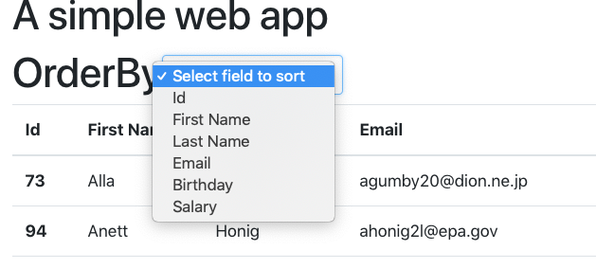

* Bonus: add **Fitler** feature, when user typing in an input, show only records that match the value of text input
* Bonus: add **Pagination** feature, table now only shows 10 records and allow user to click Next, Previous to see next, previous record

Technical Requirements:

* Must use React
* Must use Bootstrap 4 as CSS Framework